Part Number: PU550-08152

Kit Contents

|  |  |  |
| --- | --- | --- |
| Item # | Quantity Reqd. | Description |
| 1 | 1 | Cargo Liner |
|  |  |  |

Hardware Bag Contents

|  |  |  |
| --- | --- | --- |
| Item # | Quantity Reqd. | Description |
| 1 |  |  |
| 2 |  |  |
| 3 |  |  |
|  |  |  |

Additional Items Required For Installation

|  |  |  |
| --- | --- | --- |
| Item # | Quantity Reqd. | Description |
| 1 |  |  |
| 2 |  |  |
| 3 |  |  |
|  |  |  |

Conflicts

|  |
| --- |
|  |

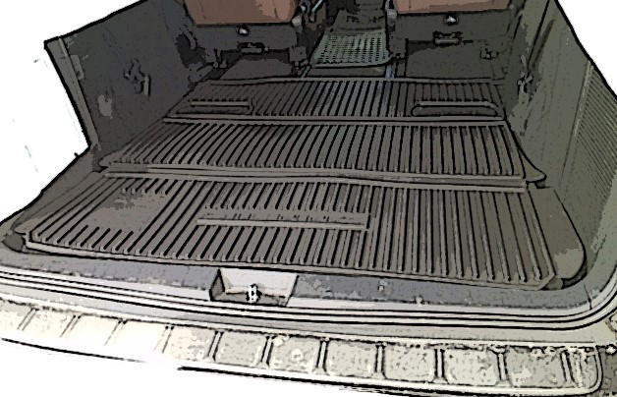Recommended Tools

|  |  |
| --- | --- |
| Personal & Vehicle Protection | Notes |
| Blankets | For rear bumper |
|  |  |
|  |  |
| Special Tools | Notes |
|  |  |
|  |  |
|  |  |
| Installation Tools | Notes |
|  |  |
|  |  |
|  |  |
| Special Chemicals | Notes |
|  |  |
|  |  |
|  |  |

General Applicability

|  |
| --- |
|  |

Recommended Sequence of Application

|  |  |
| --- | --- |
| Item # | Accessory |
| 1 |  |
|  |  |

\*Mandatory

Vehicle Service Parts (may be required for reassembly)

|  |  |  |
| --- | --- | --- |
| Item # | Quantity Reqd. | Description |
| 1 |  |  |
| 2 |  |  |
| 3 |  |  |
|  |  |  |

Legend

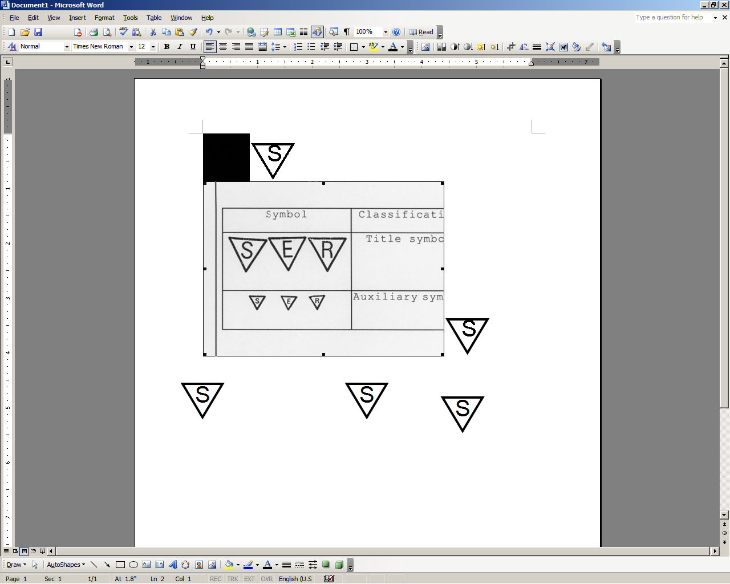

**STOP:** Damage to the vehicle may occur. Do not proceed until process has been complied with.

**OPERATOR SAFETY:** Use caution to avoid risk of injury.

**CAUTION:** A process that must be carefully observed in order to reduce the risk of damage to the accessory/vehicle and to ensure a quality installation.

**TOOLS & EQUIPMENT:** Used in Figures calls out the specific tools and equipment recommended for this process.

**REVISION MARK:** This mark highlights a change in installation with respect to previous issue.  
  
**SAFETY TORQUE:** This mark indicates that torque is related to safety.



Care must be taken when installing this accessory to ensure damage does not occur to the vehicle. The installation of this accessory should follow approved guidelines to ensure a quality installation.

These guidelines can be found in the "Accessory Installation Practices" document.

This document covers such items as:-

* Vehicle Protection (use of covers and blankets, cleaning chemicals, etc.).
* Safety (eye protection, rechecking torque procedure, etc.).
* Vehicle Disassembly/Reassembly (panel removal, part storage, etc.).
* Electrical Component Disassembly/Reassembly (battery disconnection, connector removal, etc.).

Please see your Toyota dealer for a copy of this document.

Prepare for the Installation.

* 1. Open the package and check the part for damage and kit contents.
  2. Open the tail gate.
  3. Remove any cargo and debris from the rear cargo area.
  4. Store the 3rd row seats in the down positon.

caution_2**NOTE:** Due to the shipping method, it may take up to 24 hours of warmth (room temperature) to completely form the liner to its intended shape and lie flat.

Install the Primary Cargo Liner.

* 1. Place the cargo liner in the cargo area with the logo towards the rear of the vehicle and facing up (Fig. 2-1).

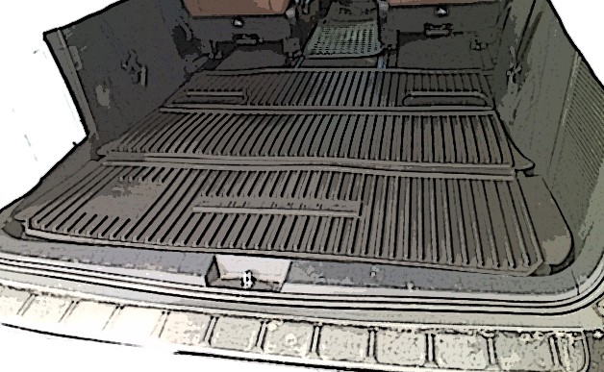

Fig. 2-1

Cargo liner

##### Storage of the Primary Cargo Liner.

* 1. The folded liner can be stored in the cargo area when the seats are in use (Fig. 3-1).

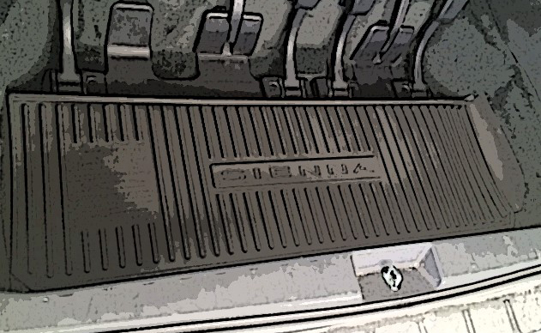

Fig. 3-1

Accessory Function Checks

Correct part number has been installed

Vehicle Function Checks

Rear tailgate closes completely

Verify part number on package

Verify tailgate fully closes

Vehicle Appearance Check

After accessory installation and removal of protective cover(s), perform a visual inspection.

Notes:

-It is Important that the cargo liner is not installed in the vehicle if the cargo area carpet is damp or wet, as mildew may result. Therefore, completely dry the carpet out before installing the cargo liner.

-The cargo liner is chemically resistant to most fluids used in normal vehicle maintenance. Great caution must be used when transporting corrosive chemicals. Should a spill occur, the liner should be carefully removed from the vehicle and washed thoroughly to prevent damage. If contact is made, follow the chemical manufacturer’s instructions and cautions.

Ensure no damage (including scuffs and scratches) was caused during the installation process.

(For PPO installations, refer to TMS Accessory Quality Shipping Standard.)